

The Royal Belfast
Academical
Institution

APPOINTMENT OF
RUGBY DEVELOPMENT OFFICER

2025

The Royal Belfast Academical Institution is an academically selective School for boys aged 11-18. The foundation stone of RBAI was laid in 1810 by George Augustus Chichester, 2nd Marquis of Donegall, and RBAI was formally opened on 1st February 1814. The School has grown and developed to become one of the leading Grammar Schools in the United Kingdom, with over 1000 pupils in the Main School and around 150 in the Preparatory Department, Inchmarlo.

At RBAI we provide a broad, balanced and progressive curriculum, throughout the School. The Revised KS3 Curriculum is embedded into departments and through cross curricular initiatives, with the Learning for Life and Work programme providing an excellent pastoral foundation for academic achievement. GCSEs are offered in over 25 subjects, including Computer Science/ICT, PE, Business Studies, Media Studies, Astronomy, Latin and Further Mathematics. At A-Level pupils will take 3 or 4 A Levels or BTEC equivalents and progress to Higher Education and Apprenticeships.

Our priority is to value the individual and develop the whole person through an evidence-based well-being programme. There are opportunities for every boy to explore his strengths, and to develop effective interpersonal and teamwork skills. The range of extra-curricular opportunities is superb and all the boys are encouraged to use their time positively in extra-curricular activities, and to develop into responsible and caring people. High level Music and Drama productions are organised regularly. Our fixtures list for sport is extensive with significant National and International successes in Rugby, Hockey, Cricket, Water Polo, Swimming, Athletics, Rowing, Table Tennis, Badminton, Cross Country and Fencing. The Combined Cadet Force has been awarded the Annual Event Challenge Trophy 18 years out of the past 21 years, which is a tremendous honour and achievement. There are daily lunchtime and after School clubs, with boys participating in societies ranging from Debating and Public Speaking to Chess, Astronomy and Scouts. There are also School trips within Northern Ireland and the United Kingdom and overseas expeditions; further details are available on the School website, www.rbai.org.uk.

Pastoral support is provided by the form teacher and, where appropriate will involve one of the 6 Housemasters who have responsibility for each of the Houses, to which all boys are allocated. The House system provides an excellent structure for boys to get to know each other and to participate in positive inter-house competitions, fostering excellent inter-personal skills and personal development.

The School occupies an impressive 8-acre site in the centre of Belfast, with modern and specialised facilities. In recent years there has been extensive renovation and refurbishment and the School is extensively equipped with iPads, interactive white boards and Mac computers. In addition to the Main School, the sport facilities at Osborne, Bladon and Shaw’s Bridge are amongst the best in the UK, with an International cricket square and synthetic water-based hockey pitch.

RBAI has a well-deserved reputation for excellence in academic and extra-curricular areas of School life. We are committed to giving each boy the opportunities to make the most of his abilities, resources and time, and to gain as complete an education as possible.
RUGBY AT RBAI

At RBAI, our aim is to ensure players foster an enthusiasm for Rugby in an environment where continuous improvement enables players to achieve their highest potential, both individually and collectively. In addition to promoting sporting excellence, the Rugby Club is also proud of its inclusive approach with close to 300 pupils representing teams each Saturday.

Rugby is one of the major winter sports played at RBAI; Rugby has been played formally since 1872. The Ulster Schools’ Cup was introduced in 1876 – overall RBAI have reached 59 finals, winning the Cup 34 times and sharing it on 4 occasions. The Medallion (Under 15) competition was introduced in 1910 and RBAI have competed in 55 finals, winning 38 times and sharing the trophy on 3 occasions.

Currently, there are 20 teams, with 18 coaches, at the main school. The provision is complemented by support from volunteer coaches, clubs and alumni.

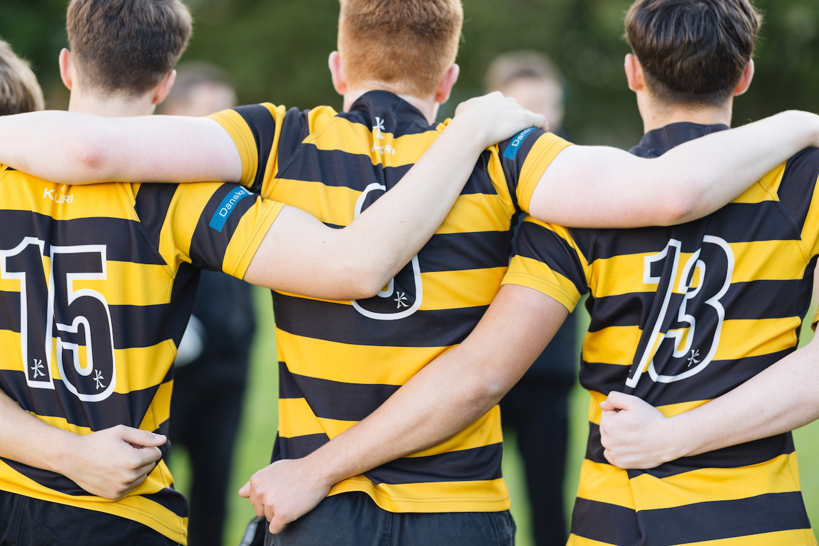

THE VACANCY

The Board of Governors is seeking to appoint a Rugby Development Officer to support and complement the work of the Director of Rugby in delivering high-quality coaching and development opportunities. The successful applicant will contribute to the delivery of RBAI’s* Rugby Curriculum, with a particular focus on players within the Foundation and Development stages of our pathway.
*RBAI includes Inchmarlo, the Preparatory Department.
Required for: 1-2 years
Responsible to: Director of Rugby; Principal
Contractual Hours: Full-time equivalent and as required to meet the needs of the
Post, including Saturdays.

MAIN DUTIES & RESPONSIBILITIES

Coaching Delivery
- Plan and deliver quality coaching, with a particular focus across Foundation and Development stages (Years 8–11), ensuring alignment with RBAI Rugby curriculum.
- Delivery of specialist skills clinics, including half backs, backs and kicking as required.
- Coach and develop a designated team as agreed with the Director of Rugby and Principal.
- Assist in quality coaching of U16 rugby players transitioning to Senior rugby.

Administration
- Plan and manage primary school outreach events and Festivals, communicating with stakeholders.
- Manage contingency fixtures, planning and communications, in light of cancellations or changes.

Individual Player Development
- Contribute to the launch and delivery of the RBAI Individual Player Development Programme (IDPs), including player-led reviews, performance analysis, and weekly goal setting.

Coach Development & CPD
- Support the DoR in implementing regular CPD for coaches.
- Share best practice to raise the quality of coaching across all stages.

Performance Analysis & Review
- Support co-ordination of filming for training sessions and matches.
- Assist in preparing clips and reports for players and coaches.

Rugby Development Plan
- Contribute to the delivery of RBAI’s Rugby Development pillars:
Quality Coaching, Rugby Curriculum, Integrated Performance, Resources & Facilities, Fixture Provision, PR & Communication.

Health, Safety & Welfare
- Ensure best practice in player welfare, injury prevention and return-to-play protocols.
- Maintain the highest standards of safeguarding and respect for the game.

Other Duties
- Tours, training camps and fundraising.

ESSENTIAL CRITERIA
- IRFU (or equivalent) Coaching Award (Youth or above).
- Proven coaching experience within school or club rugby.
- Strong organisational and communication skills.
- Commitment to player-centred development.

DESIRABLE CRITERIA
- IRFU (or equivalent) Senior/Performance Coaching Course.
- Backs Specialist
- Experience and ability to develop back line attack, half back skills and kicking.
- Experience in performance analysis (e.g. Sportscode, Hudl).
- Experience in developing and delivering CPD to coaches.
- Experience working in education.

REMUNERATION

£27,000 - £32,000 per annum

Commensurate with experience and to be discussed at interview.

APPLICATION

An application pack is available on the school website www.rbai.org.uk.
Please send a letter of application, including a CV and the names and addresses of two referees (one to address rugby experience), along with the completed Monitoring Form and Pre-Employment Vetting Declaration. Please return your application to the Principal’s PA at The Royal Belfast Academical Institution, College Square East, Belfast, BT1 6DL or by email to prinsec@rbai.belfast.ni.sch.uk.
The closing date for applications is 4pm on Friday 17 October 2025. Interviews will be held during the week commencing Monday 3 November 2025.

The School is an Equal Opportunities Employer.

PRE-EMPLOYMENT VETTING

RBAI places paramount importance on the safeguarding and wellbeing of our pupils. Consequently, we undertake pre-employment vetting of all applicants who are successful in being selected for a position at the school. This vetting includes, but is not restricted, to an Enhanced Disclosure Check with AccessNI including a barred list check for certain posts, taking up of references and examination of past employment record.

Posts involving work in the School are subject to the provisions of the Safeguarding Vulnerable Groups (Northern Ireland) Order 2007 (as amended by the Protection of Freedoms Act 2012). The successful applicant will require an Enhanced Disclosure Check and possibly a barred list check depending on the role. Further details regarding this check will be issued as part of the pre-employment vetting process

Please note that a criminal record will not necessarily be a bar to an applicant obtaining a position and any Disclosure Information will not be used unfairly. Guidance on the recruitment of ex-offenders is available at: https://www.executiveoffice-ni.gov.uk/publications/employers-guidance-recruiting-people-conflict-related-convictions.

DECLARATION BY APPLICANT

- I have read the information in this pack and all information provided in my application has been accurately provided to the best of my knowledge.

(b) I am not suffering from any medical condition which would prevent me carrying out the duties of this post in a satisfactory manner.

(c) I have not been barred by the Disclosure and Barring Service from working in Regulated Activity*

Signature of Applicant _____________________________________

Date ________________________

* Regulated Activity is work that a person working in Northern Ireland must not do if the Disclosure and Barring Service (DBS) has “barred” them from working with children and adults. It is an offence for a barred person to do such work or to apply to do such work. Further information can be found on the AccessNI website at: https://www.justice-ni.gov.uk/articles/disclosure-and-barring.

Closing date for return of application: 4pm on Friday 17 October 2025
STATEMENT OF COMMUNITY BACKGROUND

MONITORING QUESTIONNAIRE Private & Confidential

We are an Equal Opportunities Employer. We do not discriminate on grounds of
religious belief or political opinion. We practice equality of opportunity in employment and select the best person for the job.

To demonstrate our commitment to equality of opportunity in employment we need to monitor the community background of our applicants and employees, as required by the Fair Employment and Treatment (NI) Order 1998.

Regardless of whether we practice religion, most of us in Northern Ireland are seen as either Catholic or Protestant. We are therefore asking you to indicate your community background by ticking the appropriate box below.

My background is that of the Protestant community

My background is that of the Roman Catholic community

I am a member of neither the Protestant nor
Roman Catholic community background

Please indicate whether you are: Female

Male

If you do not complete this questionnaire, we are encouraged to use the “residuary” method, which means that we can make a determination on the basis of personal information on file/application form.

Note: It is a criminal offence under the legislation for a person to “give false information in connection with the preparation of the monitoring return”. This information will be treated in the strictest of confidence and protected from misuse. It will be used solely for the purpose of monitoring our equal opportunity employment policy.

